Duration: 10 Days
Prerequisites
- Knowledge on Java OOP
- Familiar with Spring Frame work and Spring Boot
- STS IDE

Day 1: Introduction to Microservices Introduction
- What & why of Microservices
- Characteristics of Microservices
- Pros and Cons of Microservices
- Microservices Ecosystem/Framework
- Popularity, Characteristics, and Challenges of Microservices
Microservices Architecture Core Concepts :- Advanced
- Overall topology and architecture components
- Remote access protocols
- Protocol-aware heterogeneous interoperability
- Service components
- Service granularity
- Bounded context
- API layer
- Inter-service communication (choreography)
- Service orchestration
- Contract decoupling
- Accessing third-party systems
- Advantages and disadvantages
- Overall topology
- Service granularity
- Database scope
- Service deployment
- Advantages and disadvantages over MicroServices
- Primary benefits
- Case studies and example architectures
- Case study: Migrating a monolith application to three core microservices

Day 2: Introduction to Spring Boot and Spring Cloud
- Introducing Spring Cloud
- Spring Cloud sub-projects: Config Server & Bus, Eureka, Ribbon, Feign, and Hystrix
- Introduction to Spring Boot
- Building a Spring Boot App

Day 3: Locating Services at Runtime Using Service Discovery
- Locating Services at Runtime Using Service Discovery
- The Role of Service Discovery and the Problem with the Status Quo
- About Spring Cloud Eureka
- Creating a Eureka Server and Using the Eureka Dashboard
- Registering a Service with Eureka
- Registering Multiple Services with Eureka
- Discovering a Service with Eureka
- Configuring Service Health Information
- Adding a Custom Health Check to a Eureka-registered Service
- High Availability Architecture for Eureka
- Advanced Configuration Options

Deployments
- Setting up a Spring Cloud Development Environment and do the deployment of single MicroServices on Pivotal Cloud , Pivotal Cloud Commands and CLI interface

Day 4: Protecting Systems with Circuit Breakers
- Protecting Systems with Circuit Breakers
- The Role of Circuit Breakers and the Problem with the Status Quo
- About Spring Cloud Hystrix
- Creating a Hystrix-protected Service
- All About the Hystrix Dashboard
- Advanced Hystrix Configuration
- What Turbine Adds to Hystrix?

Day 5: Routing Microservices Traffic
- Routing Your Microservices Traffic
- The Role of Routing and the Problem with the Status Quo
- About Spring Cloud Ribbon
- Configuring Ribbon in Your Applications
- Using Ribbon Without Eureka Integration
- How Ribbon and Eureka Work Together
- Customizing Ribbon Through Configuration
- About Spring Cloud Zuul
- Creating a Zuul Proxy with Configurable Routes
- About Zuul Filters and Stages

Day 6: Connecting Microservices Through Messaging
- Connecting Microservices Through Messaging
- The Role of Messaging and the Problem with the Status Quo
- About Spring Cloud Stream
- Understanding Binders and Configuring Stream Applications
- Creating Message Senders and Receivers
- More Options for Producing and Consuming Messages
- The Role of Processors in Spring Cloud Stream
- Creating Custom Interfaces and Using Processors
- RabbitMQ and Apache Kafka Binding Properties
- Using Consumer Groups to Scale
- Pushing Messages and Configuring Consumer Groups
- Stateful Processing with Partitions
- Working with Content Types
- Spring Cloud Stream Health and Metrics

- Spring Cloud – Zookeeper
- Spring Cloud - Security
- Spring Cloud –Sleuth
- Spring Cloud – Zipkin
- Final Considerations for Building Production-ready Systems
Making system easy for beginners
Making system complete so that it can serve as the foundation for enterprise applications

Micro Services Advanced

Day 7: Building Data Processing Pipelines Out of Microservices
- Building Data Processing Pipelines Out of Microservices
- The Role of Orchestration and the Problem with the Status Quo
- About Spring Cloud Data Flow
- About the Data Flow Server
- Consider Streams vs. Tasks
- Installing Spring Cloud Data Flow
- Getting Spring Cloud Data Flow up and Running

Day 8: Building Data Processing Pipelines Out of Micro services

- About Stream Starter Apps
- Creating Streams with Spring Cloud Data Flow
- Deploying Data Pipelines
- Creating Tasks with Spring Cloud Data Flow
- Using the Spring Cloud Data Flow Dashboard and Flo
- Building, Deploying, and Tapping Streams from the Dashboard
- Creating Custom Stream or Task Apps
- Creating, Registering, Using, and Partitioning Custom Apps
- Creating Composed Tasks
- Creating Custom Task Apps and Arranging in a Composed Task
- Monitoring Spring Cloud Data Flow Pipelines
- Updating Apps, Streams, and Tasks

Day 9 & 10 Docker

Introduction
• What is Docker
• Alternatives to Docker
• The evolution of containers
• How containers work
• Containers and Micro Service Architecture

Getting started
• Installing Docker
• Configuring Docker
• Running your first container

Docker Components
• Docker Client
• Docker Daemon

Docker Images
• What is an image
• What does an image contain
• Repositories
• Versioning & Tags
• docker images

Docker Hub
• What is the Docker Hub
• Creating an account
Docker run
• Overview
• Terminal Access
• Detached mode

Processes
• Process Ids
• Within a container
• PID
• docker ps

Logging
• docker logs
Port mapping
• Overview
• Simple port mapping

Building Images with Container Commits
• Read Only and Write layers, Copy on write
• docker commit

Dockerfile
• Introduction
• Instructions and images
• FROM
• RUN
• docker build

• build contexts
• CMD
• EXEC
• ENTRYPOINT

Starting and Stopping Containers
• docker ps
• docker start
• docker stop

Getting terminal access
• docker exec

Removing Images
• docker rmi

Docker Hub Repositories
• docker tag
• docker push
• docker pull

Volumes
• docker run /v
• VOLUME
• Do’s and Don’ts

Port Mapping
• docker run -P
• docker run -p
• EXPOSE

Linking
• Introduction
• docker --link

Continuous Integration
• Building Images
• Docker Hub Auto Build

Debugging Containers
• Using a volume for logging
• Docker inspect

Docker Daemon
• Starting and Stopping the Daemon
• Configuration
• Logging Level

Optional Topics for on-site / custom Docker Training
These topics span in total 2 days of additional course content and can be included in extended / custom on-site Docker courses.
• Security
• Private Registry
• Docker Machine
• Docker Compose
• Docker Swarm
• Kitematic
• Putting it all together - Microservices End-To-End

Case Study
API Banking Integrated
Digital Ecosystem Experience for your Retail Banking Journey

Business Context
UK government set up the Open Banking Working Group for banks and FinTechs to develop a framework for an open API standard. This business focus also stems from millennial consumers’ desire for dynamic experience across channels and value chains. API Banking will empower banks to enhance their digital offerings using an ecosystem of 3rd party applications and services to realize new revenue streams. It also helps achieve faster innovation which banks can’t ignore.

API Banking solution
Virtusa has a strong API integration framework for a vast array of web services, which helps to deliver seamless, integrated service experience. Our versatile API Lifecycle solution supports your journey to a future ready bank integrated with the new value chain for the millennial customers. The key features of the solution include:
- IBM API banking partnership with sample digital banking API demos
- Consulting services to access bank’s maturity to adopt API banking features, and design roadmap to create, run, manage and secure new micro-services that results in better, cheaper, innovative experience
- Sample apps on API covering mobile banking use-cases like cash management, account summary, spend patterns, etc
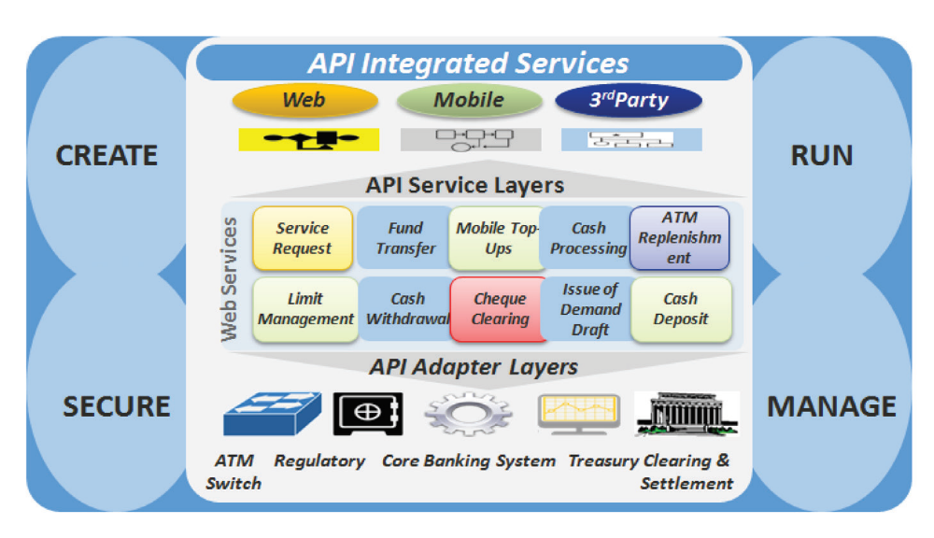

Business Benefits
- APIs allow mobile apps and websites to access banking data from multiple sources giving clients a holistic view like integrating rewards program with retailer partners
- Expand brand with new partner ecosystems. Add new revenue streams and accelerate innovation
- Reduce build cost by tapping into a wider community
- Reduce constraints on legacy technology issues and scale up business with agility

Sample Use Case
- Assisted Services (Skype, Whatsapp, etc) integrated through API connects and secured
- eKYC and customer authentications in a secured way through API integrations with national identification database API

